Fig. 1
From: Autopsy-based histopathological characterization of myocarditis after anti-SARS-CoV-2-vaccination
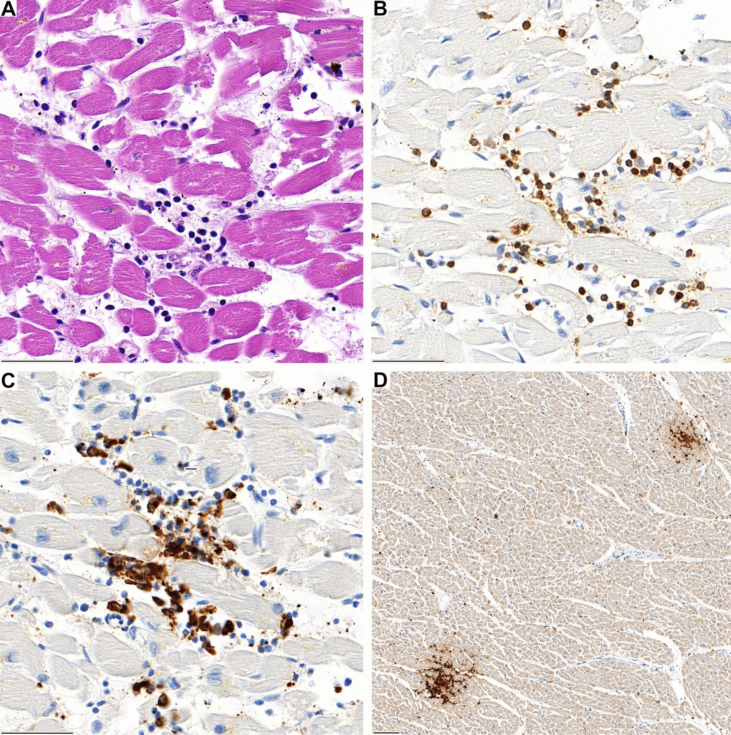
A Lymphocytic aggregates in the interventricular septum of case 1 with associated myocardiocyte destruction. B The infiltrate is predominantly composed of CD3-positive T-lymphocytes and C CD68-positive macrophages. D In lower magnification two foci of CD4-positive lymphocytes are evident (D)

Fig. 2
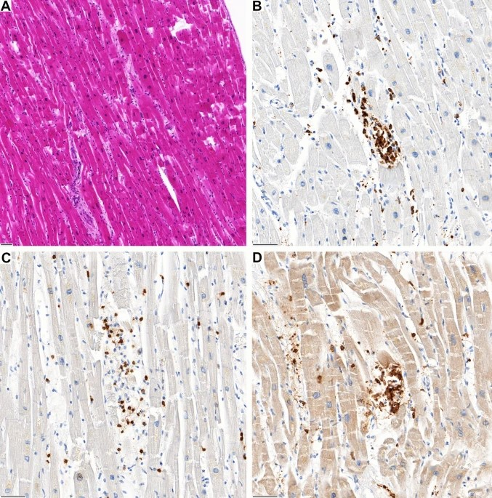
A Inflammatory focus in the left ventricular wall of case 2. B The infiltrate is predominantly composed of CD68-positive macrophages and C CD3-positive T-lymphocytes with (D) co-expression of CD4

Fig. 3
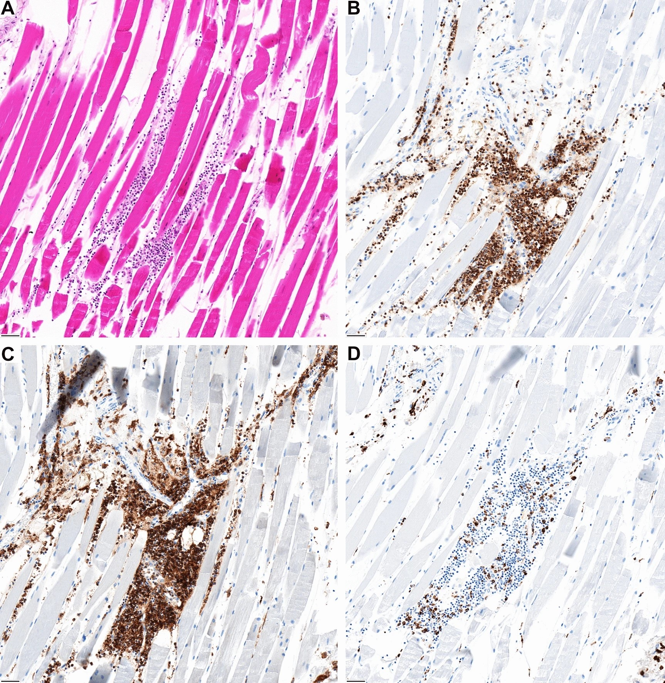
A The jab site in the deltoid muscle reveals focal inflammation. The composition is similar to the phenotype of the myocardial infiltrates showing predominantly, B CD3 and C CD4-coexpressing lymphocytes and D interspersed CD68-positive macrophages

